***Hephzibah Charter Foundation, Inc.***



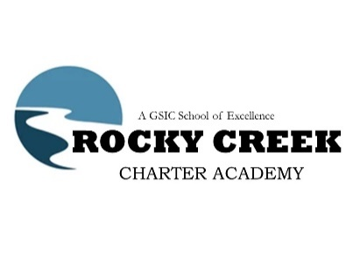

**Georgia School for Innovation and the Classics**

***Meeting Agenda for May 21, 2024***

**CALL TO ORDER**

1. **Administrative Functions**
   * Approval of Agenda
   * Approval of Minutes
2. **School Related Reports**
   * School Report
3. **Financial Reports**
   * Monthly Financial Reports
4. **Old Business**
   * No Old Business.
5. **New Business**
   *  FY24 DRAFT AMENDED BUDGET – First Reading
     1. Public Comment on FY24 Draft Amended Budget – First Reading
     2. Board Discussion
     3. Public Comment on FY24 Draft Amended Budget – First Reading
   * FY25 DRAFT BUDGET (GSIC)– First Reading
     1. Public Comment on FY25 Draft Budget – First Reading
     2. Board Discussion
     3. Public Comment on FY25 Draft Budget – First Reading
   * FY25 DRAFT BUDGET (RCCA) – First Reading
     1. Public Comment on FY25 Draft Budget – First Reading
     2. Board Discussion
     3. Public Comment on FY25 Draft Budget – First Reading
6. **Next Meeting Date**
   * June 18, 2024

**ADJOURNMENT**